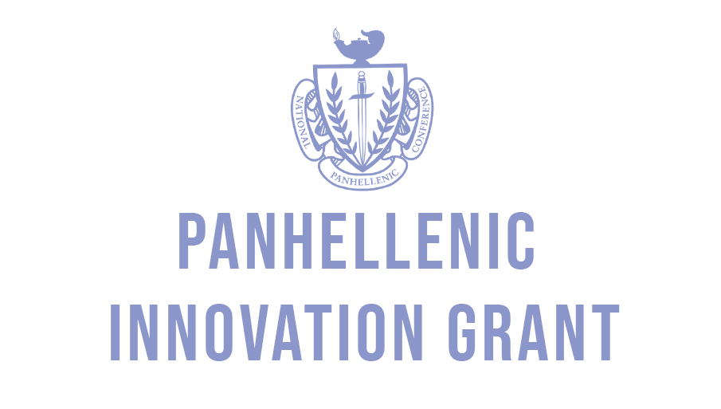

Below is the application for the 2020 Panhellenic Innovation Grant. The purpose of this grant is to foster and grow your current sisterhood. The grant can be used for a retreat, speaker, or anything beneficial for both your chapter and the Penn State Community. Please do not feel constrained to a particular budget, we want you to be as creative as possible with your ideas. However, we do ask that you provide an estimated budget attached to this application, broken down by expense. Please submit the completed application with the budget by NOVEMBER 20th in 218 HUB in the mailbox labeled VP Finance.

If you have any questions please email finance@pennstatephc.org
Thank you!

- Please provide an overview of how your chapter would use the grant.

- How will the grant better your individual chapter members?

- How does your chapter currently contribute to the Greek community?

- How will receiving the grant better the Penn State Community?

